CODING ACTIVITY 3.2 SOLUTION

Task

Create a function that works like a calculator.

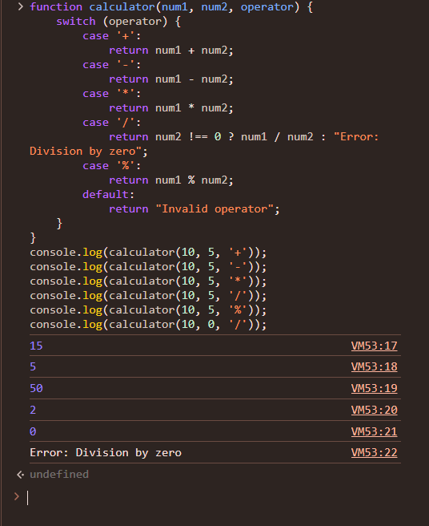

Task

Compare Objects by passing objects into function.

